

2026 Holiday Calendar
Harbor Child Care Centers will be CLOSED on the following days:
HOLIDAY DATE OBSERVED
New Year’s Day  Thursday, January 1, 2026
Martin Luther King, Jr. Day  Monday, January 19, 2026
President’s Day  Monday, February 16, 2026
Memorial Day  Monday, May 25, 2026
Juneteenth Day  Friday, June 19, 2026
Independence Day  Friday, July 3, 2026 (Observed)
Labor Day  Monday, September 7, 2026
Columbus Day/ Indigenous Peoples' Day  Monday, October 12, 2026
Professional Development Day  Wednesday, November 11, 2026
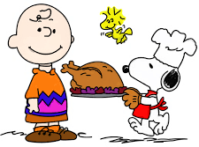
Thanksgiving Day Thursday, November 26, 2026
Day After Thanksgiving 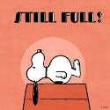 Friday, November 27, 2026
Christmas Day 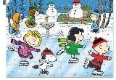 Friday, December 25, 2026

